2K20/CO/072 Ankit Kumar

Q1.

int maxElement(struct Queue \*Q) {

    int max = dequeue(Q);

    int temp = max;

    while (size(Q) > 0) {

        temp = dequeue(Q);

        if (temp > max)

            max = temp;

    }

    enqueue(Q, temp);

    return max;

}

------------------------------------------------------------------------------------------------

Q2.

void mirrorTree(struct TreeNode \*root)

{

    if(root == NULL)

        return;

    mirrorTree(root->left);

    mirrorTree(root->right);

    struct TreeNode \*temp = root->left;

    root->left = root->right;

    root->right = temp;

}

------------------------------------------------------------------------------------------------

3rd on next page

Q3.

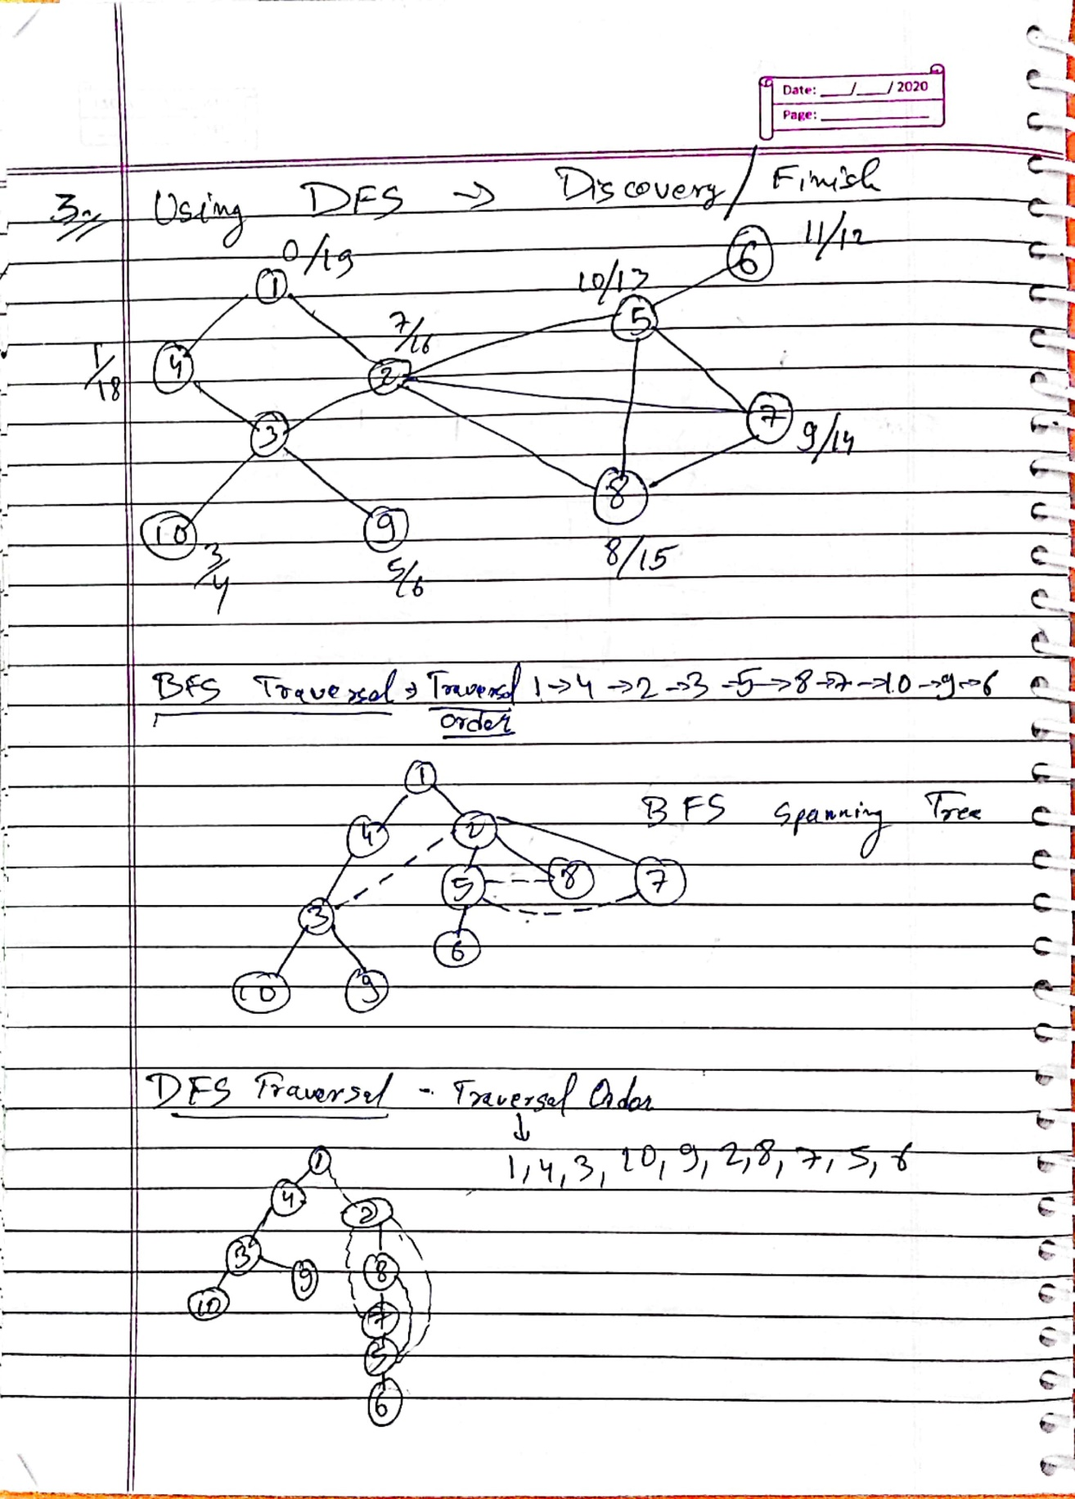------------------------------------------------------------------------------------------------

Q4.

IsTree():

   mark u as visited;

   for all vertex v which are adjacent with u:

      if v is visited:

         if isCycle(v, visited, u) return true

         else if v ≠ parent return true;

   done

   return false